**LM2596S DC to DC Buck Converter Adjustable Power Supply Step Down Module**

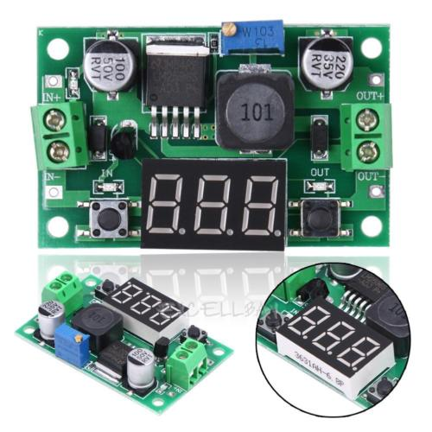

**Description:**

**Features:**

With voltage display function, the displayed accuracy is ± 0.05V, range is 0 - 40V.( Note: in order to voltage display more accurate, please ensure that the input voltage is higher than 4V).

Button to switch measurement of the input or output voltage, and LED indicates the current measurement of the input or output voltage.

The nixie tube can be turned off by another button.

Mentioned in these states are able to be memorized, is not lost even if the power is disconnected.

Continuously adjustable output voltage range of 1.25V -37V, 4-40V input voltage range.(The input voltage is at least high than the output voltage of 1.5V).

High efficiency,150 kHz fixed frequency internal oscillator.

Guaranteed 3A output load current.

Thermal shutdown and current limit protection.

**Specification:**

Input voltage range: 4-40V

Output voltage range:1.25V -37V

Output current: 2 A continuous output.

Output power: the maximum 15W

Ripple frequency: 150 KHZ.

Grain wave peak: 100MV

Voltmeter precision: ± 5 %

Product size: approx. 55*35*17mm/2.16*1.37*0.66''

Single weight: approx. 18g

Quantity: 1pc

**Note:** Please allow 1-3mm differs due to manual measurement.

Due to the different display and different light, the picture may not reflect the actual color of the item. Thanks for your understanding.

**Included:**

1 x Module